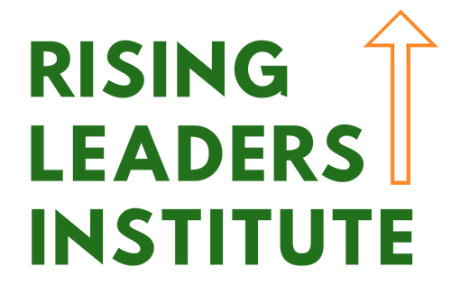
A Young Nonprofit Professionals Network of Greater Omaha (ynpnGO) program featuring Nonprofit Association of the Midlands (NAM) sponsored content, the Rising Leaders Institute (RLI) is a one year, cohort-based program that gives young nonprofit professionals the opportunity to learn the skills necessary to achieve a nonprofit leadership position through mentoring and facilitated discussion with subject matter experts.

Expectations of RLI participants:
- Attend all six regular sessions:
  - Feb 18, Apr 21, June 16, Aug 18, Oct 20, Dec 15
  - Sessions are 1-5 pm, held at the NAM office
- Be a member of ynpnGO ($25 annual dues) and attend at least four events outside the institute framework
- Pay $100 tuition

Why invest in employees applying for RLI:
- NAM staff and subject matter experts and leaders in the nonprofit field facilitate programming.
- Sessions focus on Leading Self, Leading Others, and Leading Organizations. Topics include:
  - Emotional intelligence and self-awareness in the workplace
  - Managing up
  - Project management.
- Participants will have opportunities to learn through small group discussion and exercises, and are encouraged to practice techniques in their workplace.
- Develop deep relationships and a network of among class members.
- All class members receive recognition at the annual NAM Summit.

Testimonial from RLI Class 1 member Mia Laustrup:
“Rising Leaders Institute has challenged me to come out of my comfort zone and helped connect me with a great mentor who has empowered me to see my potential and inspires me to continue to grow.”

To learn more about this program, please visit: http://www.ynpngomaha.org/program_rising_leaders_institute

